# Lab 05_01 -- Chapter 05 -- Grading Program

## Lab Description:

Write a grading program for an instructor whose course has the following policies described below (pg 371, #1, Savitch) and follow the directions.

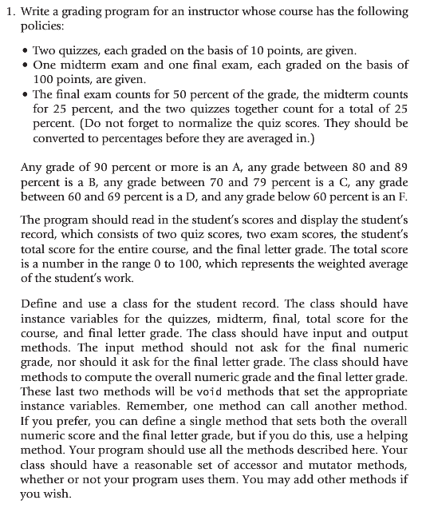

Note, a weighted average can be computed using the following formula:

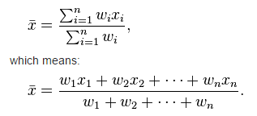

Note, the denominator is equal to one for our example. I have attached a spreadsheet that demonstrates calculating a weighted average for this lab.

## Lab Requirements:

1. The class should be named StudentGrade.java
2. Use JOptionPane or Scanner to interface with the users
3. You should create a second “driver” class that tests your StudentGrade.java
   1. StudentGradeDemo.java
4. Use constants where appropriate.
   1. Weightings and etc
5. Use Java formatting conventions
6. Use comments where appropriate
7. Create a short document explaining how you tested your program.
8. Submit your testing document to Blackboard.
9. Submit your source code to Blackboard
   1. Remember, your submitted source code must compile or a zero will be given